STAFFING FOR PLAST CAMPS

Policy

Leaders (in-camp or tripping) shall have the skills, knowledge, training, experience, and judgement to successfully perform their assigned duties.

All individuals shall complete a CAMP STAFF APPLICATION FORM prior to being accepted/hired/appointed as a leader.

All leaders shall provide Plast Canada with a current Police Record Check.

Explanatory Material

In addition to the wide variety of Plast Camp types, locations, and activities, there are also myriad of roles. As a result of this highly case sensitive situation, due care and consideration must be devoted to ensure that the set of skills required to operate a safe and effective camp are in place. A typical organizational structure is depicted below.
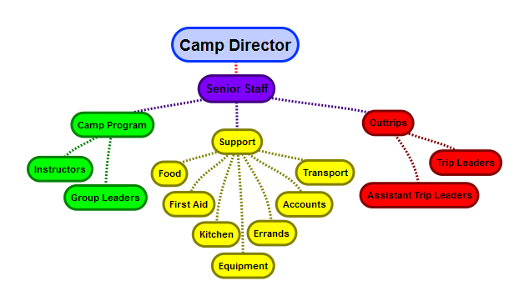
Procedures

- The camp director (or designate) will assign leaders to roles.

Guidelines

The following job descriptions outline the functional tasks of various Plast camp leaders.

Camp Director | - Recruits, interviews, and participates in the hiring of in-camp group leaders, trip leaders, and senior staff  - Effectively supervises, coaches, and mentors in-camp group leaders, trip leaders, senior staff, and support personnel  - Defines camp goals and plans a program to reflect camp goals  - Prepares and conducts pre-camp and in-service staff trainings  - Orders or supervises the ordering of food, supplies, and equipment, and arrange for proper distribution  - Develops routines, schedules, and procedures for camp operation.  - Assigns staff activities and other responsibilities  - Assigns staff and campers to groups  - Defines and monitors the camp’s crisis management plan, including emergency procedures  - Organizes and/ or approves trips out of camp for program activities, supplies, and crisis management  - Monitors safety and all procedures as they pertain to the complete supervision of all campers and staff
In-Camp Group Leader | - Assumes responsibility for leadership and guidance to campers in daily living skills, with special attention to:  - Personal hygiene, safety & manners  - Camper personal interactions with respect of others  - Camper participation in all camp activities  - Camper personal growth, self-confidence and independence through group living  - Serves as a good role model to campers in personal language, appearance, manners and healthy habits  - Implements Plast’s leadership development program which empowers Scouts to try on roles of leaders and supporters  - Teaches relevant outdoor skills
Trip Leader | - Undertakes responsibility for the entire life cycle of the trip from beginning to end  - Recognizes and responds effectively to incidents and emergencies  - Provides proper emergency care when necessary  - Able to effectively teach participants and train fellow leadership team members  - Able to lead trips without direct supervision by the Camp Director
Assistant Trip Leader | - Assists the trip leader in the overall facilitation of an assigned trip  - Creates and fosters meaningful environments for trip participants, while simultaneously ensuring the mental and physical safety of each individual  - Learns and assists the trip leader in teaching specific skills sets for each of the respective trips (camping, backpacking, canoeing, rock climbing, etc.)  - Provides clear instructions to participants
General

All leaders should be a minimum of 18 years of age.

A leader should be at least 2 years older than the oldest participant in the Scout group with which he/she is working.

All leaders should have current certification in Standard First Aid (8 hours) or equivalent.

In-Camp

In-camp group leaders shall be current Plast members.

Senior Staff

Any individual assuming a senior staff role shall have experience as a camp leader (tripping or in-camp).

Tripping

When a trip ventures 2 or more hours from definitive care, it is desirable for at least one member of a Trip Leadership Team to be certified in Wilderness First Aid (16 hours) or higher.

At least one member of a Trip Leadership Team shall be a current Plast member (i.e. dues paid).

On co-ed trips there should be at least one male and one female member on the Trip leadership team.

A trip leader should have acquired experience as an assistant leader on a prior trip of similar duration and level of difficulty.

An assistant trip leader should have prior tripping experience (may be acquired as a participant) commensurate with the length of the trip and its degree of challenge.

Definitions

Leader | Any individual who assumes direct supervisory or activity design and delivery responsibilities with a group of Scouts during a Plast camp.
In-Camp | Refers to those activities that take place at the main campsite.
Trip Leadership Team | A group of at least two leaders per trip who assume joint responsibility for meeting all of the campers’ needs in the absence of the support from other camp staff and facilities.
Trip Leader | Leader who assumes primary instructional and risk management responsibilities for a trip group and serves as a mentor to the assistant trip leaders.
Assistant Trip Leader | Leader who is expected to assume leadership for a trip group in the event of an emergency but may still be developing his/her instructional and supervisory skills.
Senior Staff | Individuals whose role at camp is primarily concerned with the functioning of the camp program as a whole. Typical examples of senior staff include: the assistant camp director, the program director/head counsellor, the scribe.
Role | The set of tasks and obligations assigned to / performed by an individual that are tied to a particular position within the broader organizational system of camp.
Trip | A planned excursion away from the main campsite ranging from a picnic in a nearby park to a canoe trip in the wilderness. Trips vary in purpose, duration, location and mode of travel. During the trip the group is independent of the support services available at the main campsite. On most Plast camp trips, the group is autonomously travelling through a remote or wilderness area.

References

Forms

Plast Canada – CAMP STAFF APPLICATION FORM

Administration

Policy Title:
Policy #: |  | Policy Date:
Total Pages: | ## | Revised Date:
Approved by: |  | Reviewed Date:

